**File Tracking System**

**(Internship Project Report)**

**Name :- SAYAN ROY**

**Institute :- KIIT University,Bhubaneshwar**

**Branch :- Computer Science & Engineering**

**Year of study :- 2nd year // Roll no.:- 1405338**

**Trainer :- Mr.R.K. Ghosh (CIL(System))**

**Duration :- 12th May to 6th June , 2016**

**ACKNOWLEDGEMENT**

The help and constant support I have got from my trainer Mr.R.K. Ghosh (especially in helping me set up a link between my back-end(Oracle) and front-end(eclipse IDE) and also some seniors in the System department of Coal India Limited headquarters in Kolkata is very much appreciated.

**INTRODUCTION**

File Tracking System ,as the name suggests,helps to track the files relevant to you( and your department if you are an HOD) which can get very difficult to track and search manually. It can also be referred to as document management system and the idea can be implemented for any company as long as every employee is accessed to a database by a PC.

The basic idea is as follows:-  
Someone wants to initiate a file ,he/she writes the necessary details on the system like in a virtual diary and the details are stored in the database.   
The file has then,gone through subsequent forwards from many employees depending upon the general office hierarchy(Chair > HOD > Employees) . The employees along with other details like their departments through which the file has gone through are also stored in the database.  
Now,suppose,after few days, that initiator employee wants to know where that file is , the computer automatically tells in a matter of milliseconds and s/he does not have to keep on asking his/her colleagues.  
Any employee can also see which are the files currently forwarded to him(or other employees of his/her department in case of an HOD) at that given moment.  
  
The program has a lot of other features ,too,catering to the specific needs of any kind of employee ( Chair,HOD or other employees), which I think , might be useful.

**WORKING AND MECHANISM**

**Technology used:-**

* Back end – Oracle 10.2.0 , JDBC driver (ojdbc 14_g)
* Front end – Java on Eclipse Mars IDE (**989 lines of java code written(excluding SQL queries in sqlplus)**)

**Relation Tables:-**

* **Master table**:-

Relation schema ->

Name Null? Type

-------------------------------------------------------------------------

-------------------------------------------------------------------------

USERNO

NOT NULL NUMBER(4)

USERNAME

VARCHAR2(30)

DEPNO

NUMBER(3)

ETYPE

VARCHAR2(20)

PASS

VARCHAR2(20)

Snapshot - >

USERNO USERNAME DEPNO ETYPE PASS

---------- ------------------------------ ---------- -------------------- -------------------- ----------

330 Mr.Shekhar Roy 101 hod sys330

331 Mr.R. Nandi 101 e1 sys331

332 Mr.N. Pandey 101 e2 sys332

335 Mr.R.K. Ghosh 102 hod sys335

.

.

.

700 Mr.Sayan R. 0 chair tmvrises

* **Department table :-**

Relation schema ->

Name Null? Type

----------------------------------------- -------- ----------------------------

DEPNO NOT NULL NUMBER(3)

DEPNAME VARCHAR2(20)

Snapshot ->

DEPNO DEPNAME

---------- -----------------------------

101 Finance

102 System

103 Personal

104 Material Management

105 Human Resource

0 ALL

* **Transaction table :-**

Relation schema->

Name Null? Type

---------------------------------------------------------------------------

---------------------------------------------------------------------------

FILENO

Not null NUMBER(4)

FILESUB

VARCHAR2(35)

FORBY

VARCHAR2(30)

FORTO

VARCHAR2(30)

SDATE

VARCHAR2(25)

EDATE

VARCHAR2(25)

STATUS

VARCHAR2(10)

MONEY

NUMBER(10)

DEPFR

VARCHAR2(20)

DEPTO

VARCHAR2(20)

Fileno - Unique file no for a particular file

Filesub – Subject of the file

forby- Username of the person who has forwarded the file

forto- Username of the person to whom it has been forwarded

sdate- Date and time when the file has arrived to the particular employee

edate- Date and time when the file has departed from the particular employee

status- “Initiated” means the file is initiated by the employee

“Through” means the file passed through by the employee

“Now” means the file is currently present on the employee

money-Money involved in the file

depfr- Dept name of the person who has forwarded the file

depto- Dept name of the person to whom it has been forwarded

**User interface**:-

It is a command line interface with user-friendly instructions giving the user ability to exit from the system and going to the main menu at his/her command.

* Start-up authentication/login :-

A user is asked to give his/her user number and password . S/he has got five attempts to enter the correct credentials otherwise the user gets an automatic exit ensuring security.

**MAIN MENU ->**

* Logout:-

The user gets prompted into the start-up login again.

* Initiate:-

The user is asked to give the file subject and money involved.

File no. is automatically generated .

Forby and depfr is of the current employee

Status is “initiated”

Sdate is the current date and time.

User is asked whether to go to main menu,exit or forward.

If forward is chosen,the user asked to whom s/he wants it to be forwarded to.Then,forto is automatically generated and status of the next record becomes “Now”.

FOR AN HOD - >

HOD can forward the file to the employees of his department,other HODs and the chair.

FOR CHAIR ->

He can forward it to anyone.

FOR OTHER EMPLOYEES ->

He can forward it to employees of his dept and his HOD.

If the user tries to forward file outside of his domain,he is asked to try again.

* Check-n-track your files :-

FOR AN HOD - >

1.Files initiated by you 2.Files currently fwd to you

3.Files initiated by your dept 4.Files currently fwd to your dept

5.Back to MAIN MENU 6.Exit

He is asked to enter the option.

**1.**For option 1:- He is shown all the records of the transaction table of the files which have been initiated by him.

He is asked if he wants to forward any file or not.If he enters the file no. of a valid file(which he has not forwarded yet) ,the file will be forwarded accordingly. If he does not enter a valid file no,he is asked to try again.

**2.** For option 2:-He is shown all the records of the transaction table of the files which have been forwarded to him and for which he is the current holder.

He is asked if he wants to forward any file or not.If he enters the file no. of a valid file(which he has not forwarded yet) ,the file will be forwarded accordingly. If he does not enter a valid file no,he is asked to try again.

**3.**For option 3:- He is shown all the records of the transaction table of the files which have been initiated by him or other employees of his department.

He is asked whether to show it as per order of money involved or initiation date.

**4.**For option 4:- He is shown all the records of the transaction table of the files which have been forwarded to the employees of his dept incl. him and for which they are the current holder.

He is asked whether to show it as per order of money involved or initiation date.

FOR A CHAIR->

1.Files initiated by you 2.Files currently fwd to you

3.Files initiated by any dept 4.Files currently fwd to any dept

5.All the files

6.Back to MAIN MENU 7.Exit

He is asked to enter the option.

**1.**For option 1:- He is shown all the records of the transaction table of the files which have been initiated by him.

He is asked if he wants to forward any file or not.If he enters the file no. of a valid file(which he has not forwarded yet) ,the file will be forwarded accordingly. If he does not enter a valid file no,he is asked to try again.

**2.** For option 2:-He is shown all the records of the transaction table of the files which have been forwarded to him and for which he is the current holder.

He is asked if he wants to forward any file or not.If he enters the file no. of a valid file(which he has not forwarded yet) ,the file will be forwarded accordingly. If he does not enter a valid file no,he is asked to try again.

**3.**For option 3:- He is asked to enter a dept number.

He is shown all the records of the transaction table of the files which have been initiated by employees of the particular department.

He is asked whether to show it as per order of money involved or initiation date.

**4.**For option 4:- He is asked to enter a dept number.

He is shown all the records of the transaction table of the files which have been forwarded to the employees of the particular dept and for which they are the current holder.

He is asked whether to show it as per order of money involved or initiation date.

**5.**For option 5 :- He is shown all the records of the transaction table.

He is asked whether to show it as per order of money involved or initiation date.

FOR OTHER EMPLOYEES->

1.Files initiated by you 2.Files currently fwd to you

3.Back to MAIN MENU 4.Exit

He is asked to enter the option.

**1.**For option 1:- He is shown all the records of the transaction table of the files which have been initiated by him.

He is asked if he wants to forward any file or not.If he enters the file no. of a valid file(which he has not forwarded yet) ,the file will be forwarded accordingly. If he does not enter a valid file no,he is asked to try again.

**2.** For option 2:-He is shown all the records of the transaction table of the files which have been forwarded to him and for which he is the current holder.

He is asked if he wants to forward any file or not.If he enters the file no. of a valid file(which he has not forwarded yet) ,the file will be forwarded accordingly. If he does not enter a valid file no,he is asked to try again.

* Search where your file is :-

FOR AN HOD->

He is asked :- Enter file no. of the relevant(initiated by you or others of your dept.) file to be searched

FOR A CHAIR->

He is asked :- Enter file no. of the file to be searched

FOR OTHER EMPLOYEES->

He is asked :- Enter file no. of the relevant(initiated by you ) file to be searched

If they do not enter a relevant file’s file number,they are asked to try again.This is to ensure the jurisdiction of domain.

If they enter the correct file no.,then the file’s current holder,money,file subject and the “sdate” is shown,that is, only one unique record is shown where the file is not forwarded to anyone yet(forto is NULL).

* Exit:-

The control gets out of the user and a message is prompted.

**advantages(pros)**

* It ensures security at the start-up login as the user is given five attempts to enter the correct credentials (username and password) .If he takes more than that,he gets an automatic exit.
* It is a highly efficient program which gets compiled in 0.0002 sec on average.This is partly because I have used parameterized functions enabling them to be called for different purposes thus minimizing the source code.Also,I have taken help of recursion.
* The user at any given moment can go to the main menu for other options and exit the program.
* The logout option ensures multiple login from a single terminal.
* The user-friendly interface ensures that if any layman user enters wrong input of any kind,he/she is told about the problem and asked to enter again.
* Deleting records from the tables can only be done by the DBA who has the necessary password to login to the database.

**limitations(cons)**

* Due to the lack of time(my examinations were underway ) ,the client-side version of the program could not be developed ,i.e.,it does not have a graphical user interface.Instead,it has command line interface.
* The passwords are not encrypted by any keys nor it incorporates any hashing algorithm,thus compromising security to an extent.
* No safety measures have been taken to prevent SQL injections.

**SCREENSHOTS OF THE APPLICATION**

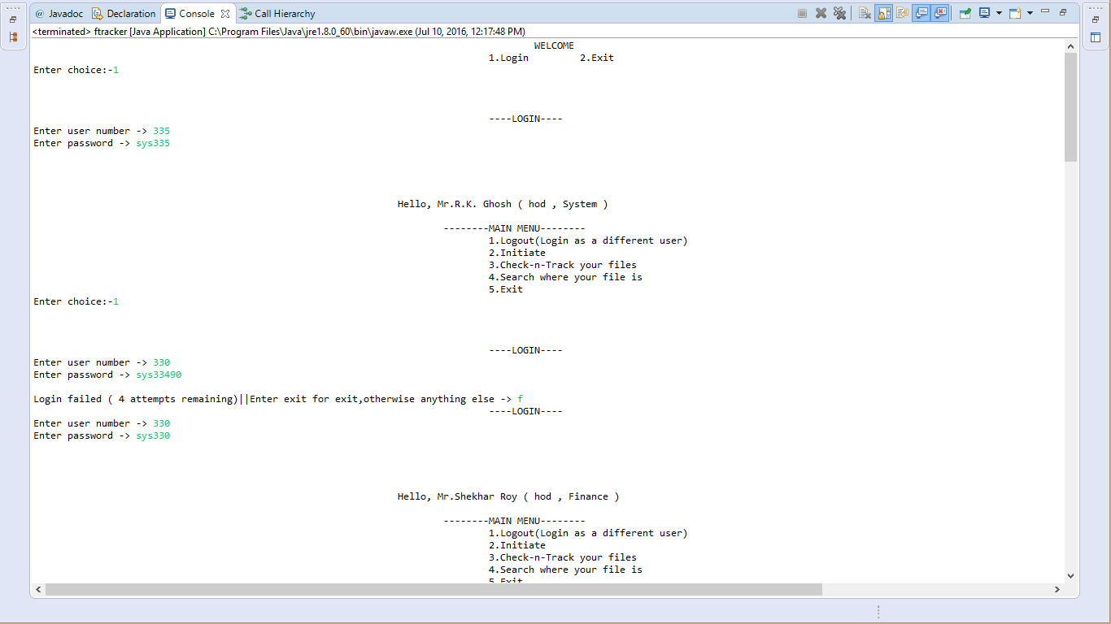

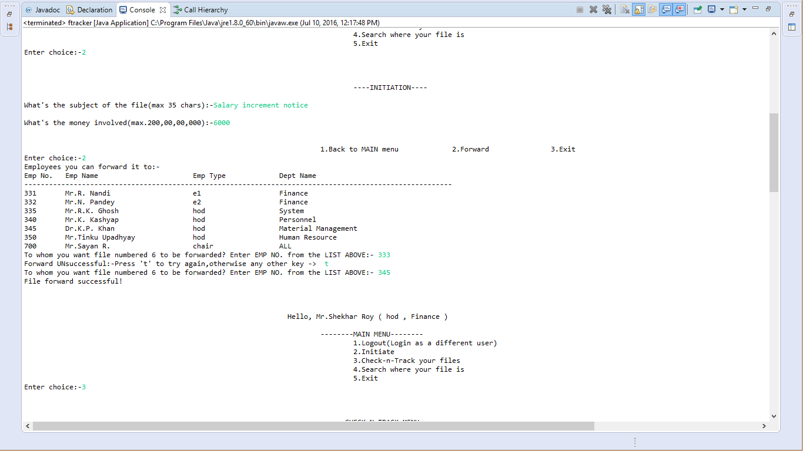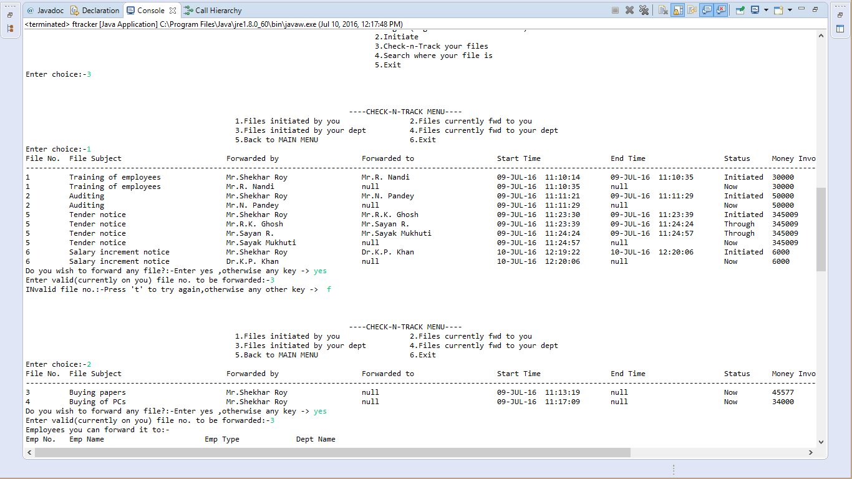

The right part of the screen is as follows:-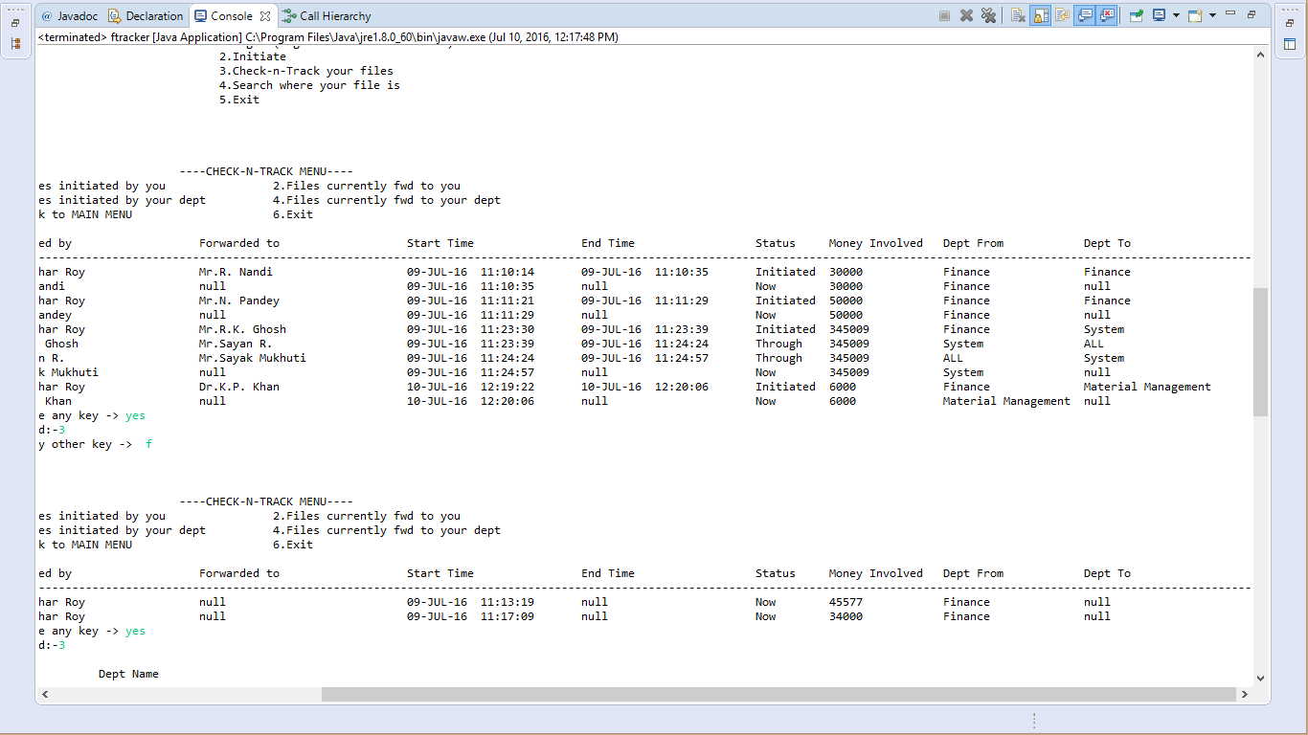

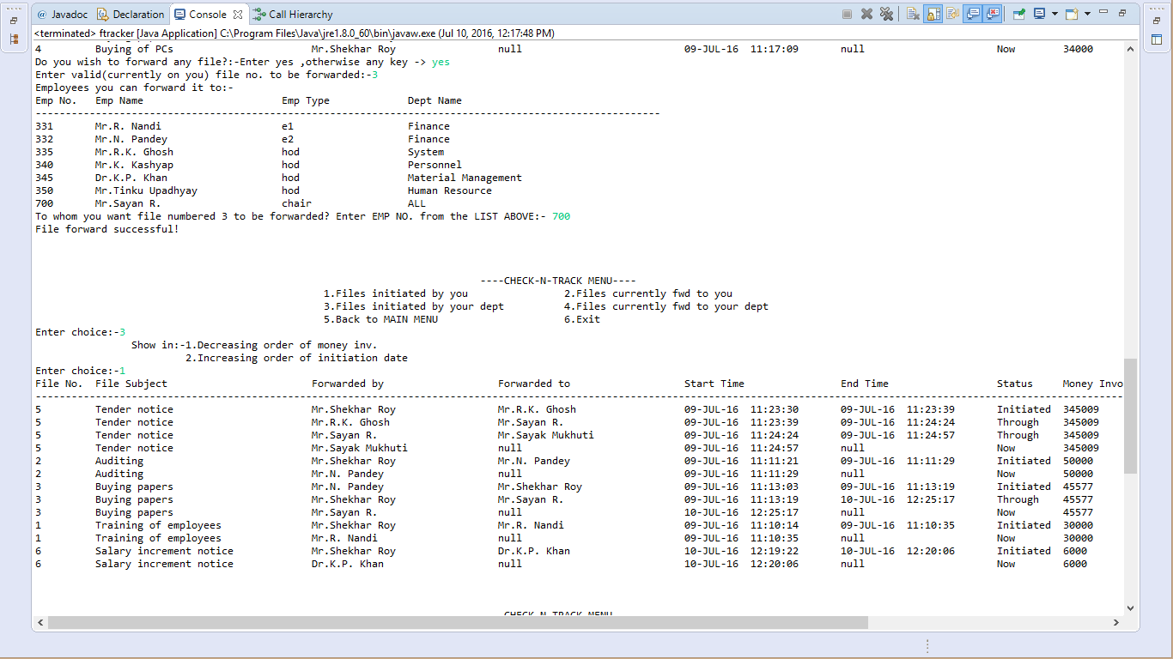

The right part of the screen is as follows:-  
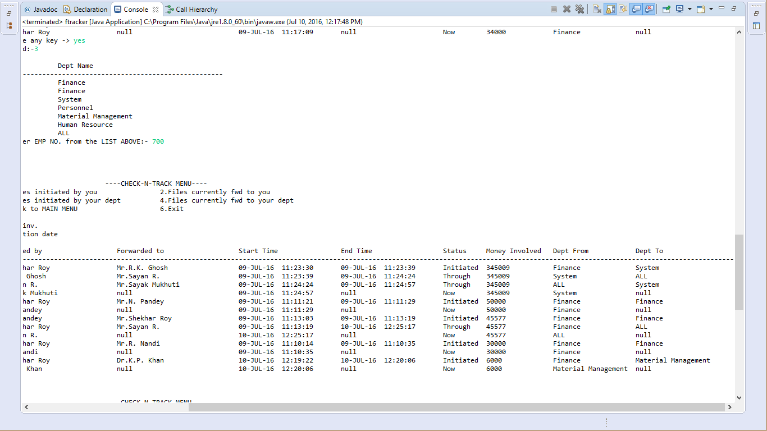

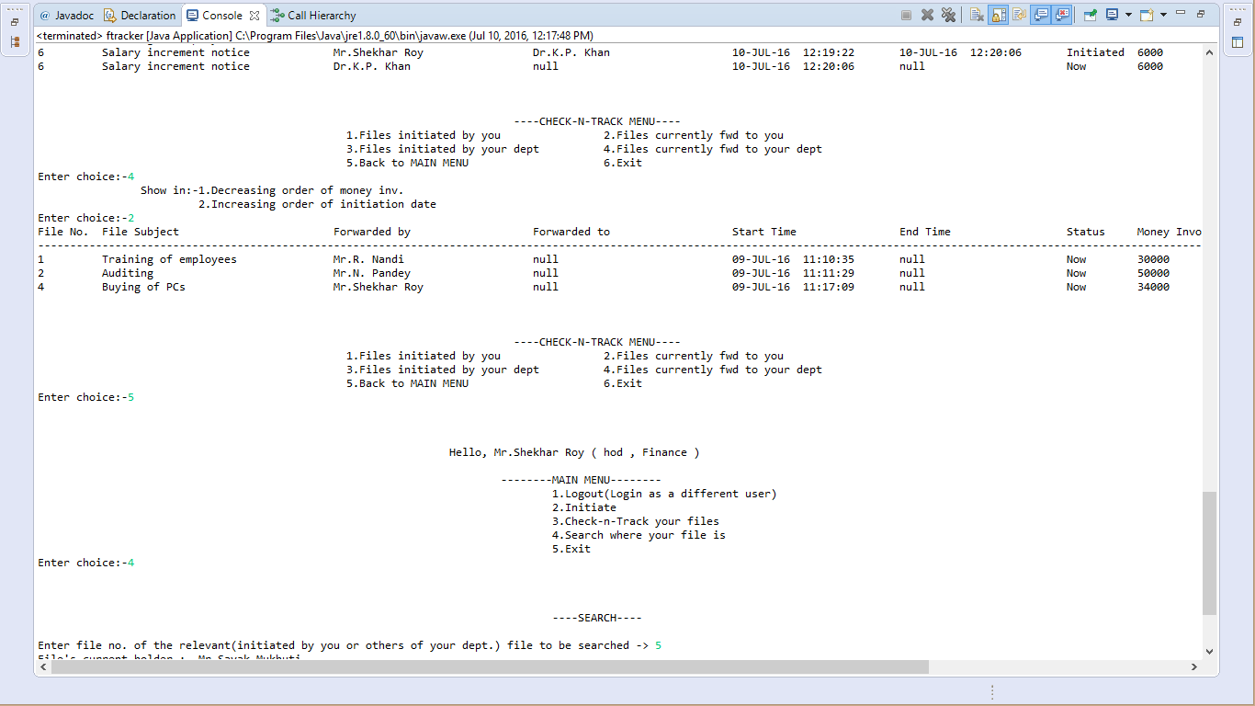

The right part of the screen is as follows:-  
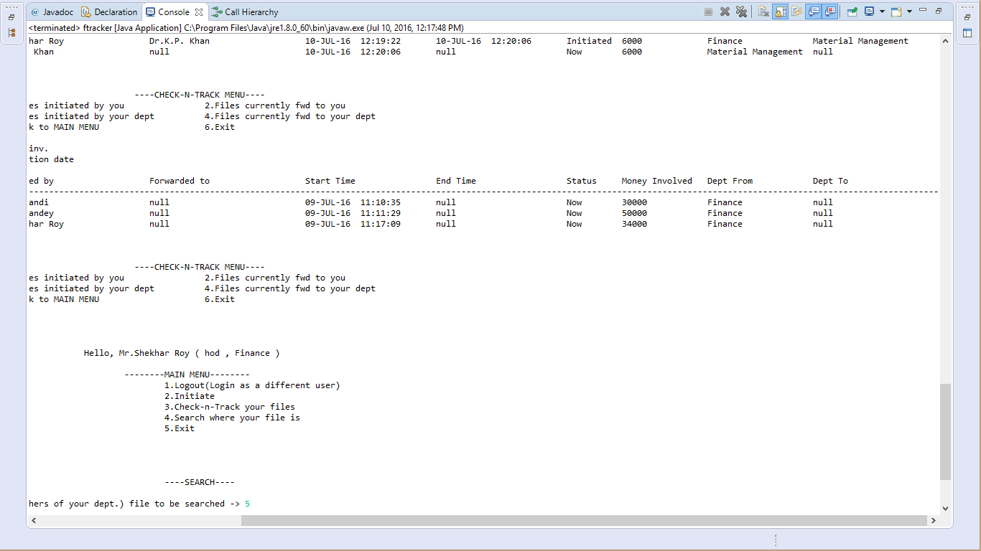

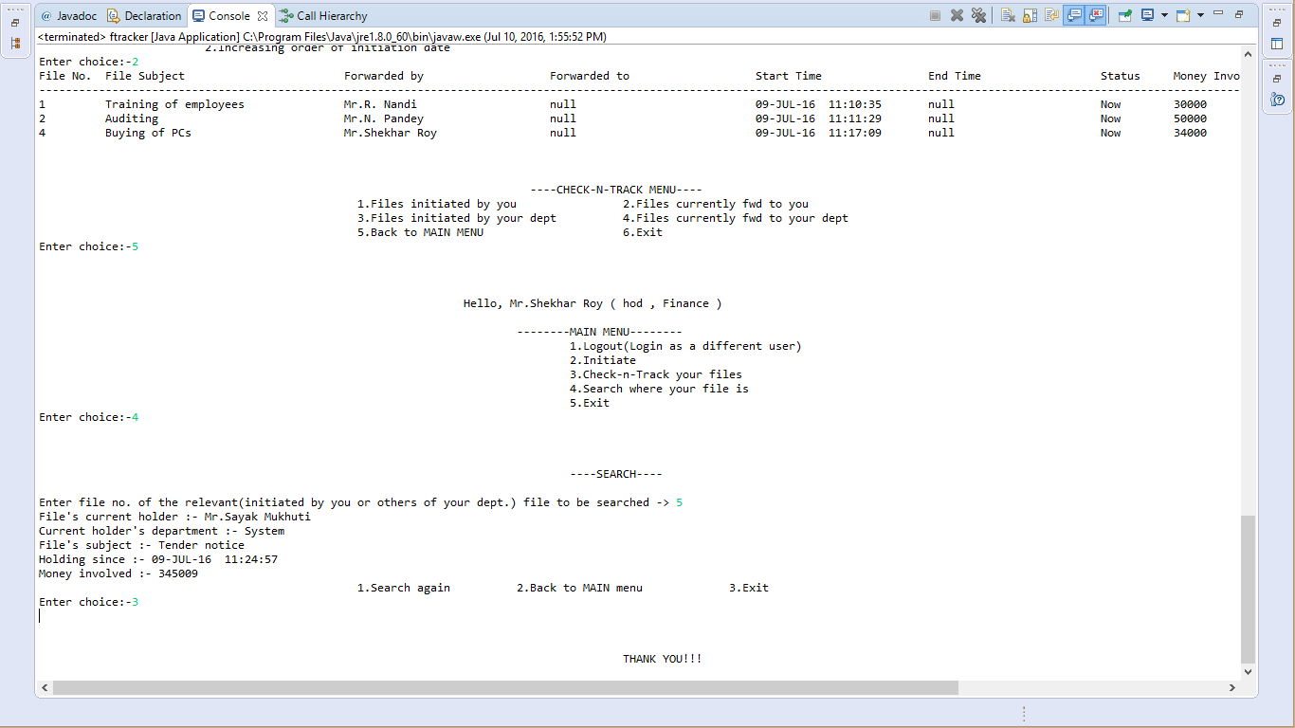

Multiple logins from a single terminal can be done and also,there are different user interfaces and instructions for each of the different types of employees ,i.e.,chair,hod and other employees. However,I have given the above outputs mainly from an HOD’s perspective.

**source code**

**package** ftpk1;

**import** java.io.Console;

**import** java.sql.Connection;

**import** java.sql.DriverManager;

**import** java.sql.ResultSet;

**import** java.sql.SQLException;

**import** java.sql.Statement;

**import** java.util.Scanner;

**import** java.util.*;

**import** java.sql.PreparedStatement;

**import** com.oracle.*;

**public** **class** ftracker

{

String uname1,pass1,etype1,depname1;

//String eno="Emp No.",ename="Emp Name",et="Emp Type",dn="Dept Name";

**int** uno1,depno1;

**static** Connection con = **null**;

**static** PreparedStatement pstmt1=**null**,pstmt2=**null**,pstmt3=**null**,pstmt4=**null**;

**void** exitf()

{

System.**out**.print("\n\n\n");

System.**out**.println("\t\t\t\t\t\t\t\t\t\t\tTHANK YOU!!!");

System.exit(0);

}

**void** menuf()**throws** Exception

{

System.**out**.print("\n\n\n");

Scanner in1=**new** Scanner(System.**in**);

ResultSet rs1=**null**;

String qm1="select username,master.depno,etype,depname from master,dept where master.depno=dept.depno and userno=?";

pstmt1=con.prepareStatement(qm1);

pstmt1.setInt(1,uno1);

rs1=pstmt1.executeQuery();

**while**(rs1.next())

{

uname1=rs1.getString(1);

depno1=rs1.getInt(2);

etype1=rs1.getString(3);

depname1=rs1.getString(4);

System.**out**.println("\t\t\t\t\t\t\t\tHello, "+uname1+" ( "+etype1+" , "+depname1+" )");

}

System.**out**.println("\n\t\t\t\t\t\t\t\t\t--------MAIN MENU--------");

System.**out**.println("\t\t\t\t\t\t\t\t\t\t1.Logout(Login as a different user)\n\t\t\t\t\t\t\t\t\t\t2.Initiate\n\t\t\t\t\t\t\t\t\t\t3.Check-n-Track your files\n\t\t\t\t\t\t\t\t\t\t4.Search where your file is\n\t\t\t\t\t\t\t\t\t\t5.Exit");

**do**

{

System.**out**.print("Enter choice:-");

**int** ch=in1.nextInt();

**switch**(ch)

{

**case** 1:

loginf();

**break**;

**case** 2:

initiatef();

**break**;

**case** 3:

checkf();

**break**;

**case** 4:

searchf();

**break**;

**case** 5:

exitf();

**break**;

**default**:

System.**out**.println("Kindly enter a valid choice");

}

}**while**(**true**);

}

**void** startf()**throws** Exception

{

Scanner in1=**new** Scanner(System.**in**);

System.**out**.println("\t\t\t\t\t\t\t\t\t\t1.Login\t\t2.Exit");

**do**

{

System.**out**.print("Enter choice:-");

// String tch=in1.nextLine();

// int ch=Integer.parseInt(tch);

**int** ch=in1.nextInt();

**switch**(ch)

{

**case** 1:

loginf();

**break**;

**case** 2:

exitf();

**break**;

**default**:

System.**out**.println("Kindly enter a valid choice");

}

}**while**(**true**);

}

**void** loginf()**throws** Exception

{

System.**out**.print("\n\n\n");

Console console=System.console();

Scanner in=**new** Scanner(System.**in**);

Scanner in2=**new** Scanner(System.**in**);

String querym="select * from master";

pstmt1=con.prepareStatement(querym);

ResultSet rs1=**null**;

**int** count=5;

String pass,a;

**do**

{

count--;

System.**out**.println("\t\t\t\t\t\t\t\t\t\t----LOGIN----");

System.**out**.print("Enter user number -> ");

uno1=in.nextInt();

//pass=new String(console.readPassword("Enter password"));

//console.printf("password entered : %s%n",pass);

System.**out**.print("Enter password -> ");

pass1=in2.nextLine();

System.**out**.println();

rs1=pstmt1.executeQuery();

**while**(rs1.next())

{

**if**(rs1.getInt(1)==uno1 && pass1.equals(rs1.getString(5)))

{

menuf();

}

}

**if**(count==0)

exitf();

System.**out**.print("Login failed ( "+count+" attempts remaining)||Enter exit for exit,otherwise anything else -> ");

a=in2.nextLine();

**if**(a.equalsIgnoreCase("exit"))

exitf();

}**while**(**true**);

}

**void** initiatef()**throws** Exception

{

System.**out**.print("\n\n\n");

System.**out**.println("\t\t\t\t\t\t\t\t\t\t----INITIATION----");

String sub,datestr=**null**;

**int** mon,newfileno=0;

Scanner in1=**new** Scanner(System.**in**);

Scanner in2=**new** Scanner(System.**in**);

System.**out**.print("\nWhat's the subject of the file(max 35 chars):-");

sub=in1.nextLine();

System.**out**.print("\nWhat's the money involved(max.200,00,00,000):-");

mon=in2.nextInt();

String query1="select max(fileno) from trans";

pstmt1=con.prepareStatement(query1);

ResultSet rs1=pstmt1.executeQuery();

**while**(rs1.next())

{

newfileno=rs1.getInt(1)+1;

}

String query2="Insert into trans(fileno,filesub,forby,sdate,status,money,depfr) values(?,?,?,?,?,?,?)";

pstmt2=con.prepareStatement(query2);

pstmt2.setInt(1,newfileno);

pstmt2.setString(2, sub);

pstmt2.setString(3, uname1);

//java.sql.Date date=getCurrentJavaSqlDate();

// Calendar cal=Calendar.getInstance();

// java.sql.Date dateobj=new java.sql.Date(cal.getTime().getTime());

String query3="select to_char(sysdate,'dd-MON-yy hh24:mi:ss') from dual";

pstmt3=con.prepareStatement(query3);

ResultSet rs2=pstmt3.executeQuery();

**while**(rs2.next())

{

datestr=rs2.getString(1);

}

pstmt2.setString(4,datestr);

pstmt2.setString(5,"Initiated");

pstmt2.setInt(6,mon);

pstmt2.setString(7,depname1);

pstmt2.executeUpdate();

System.**out**.println("\n\n\t\t\t\t\t\t\t\t\t1.Back to MAIN menu\t\t2.Forward\t\t3.Exit");

**do**

{

System.**out**.print("Enter choice:-");

**int** ch=in1.nextInt();

**switch**(ch)

{

**case** 1:

menuf();

**break**;

**case** 2:

forwardf(newfileno,"init");

menuf();

**break**;

**case** 3:

exitf();

**break**;

**default**:

System.**out**.println("Kindly enter a valid choice");

}

}**while**(**true**);

}

**void** forwardf(**int** fno,String from)**throws** Exception

{

Scanner in1=**new** Scanner(System.**in**);

Scanner in2=**new** Scanner(System.**in**);

ResultSet rs1,rs2,rs3;

**int** eno1,earr[]=**new** **int**[100],count=0,flag=0,fmon=0;;

String ch,enarr[]=**new** String[100],dnarr[]=**new** String[100],fsub=**null**,q3=**null**;

**if**(etype1.equals("hod"))

{

System.**out**.println("Employees you can forward it to:-");

String q1="select userno,username ,etype,depname from master,dept where (master.depno=dept.depno and (master.depno=? or etype='hod' or etype='chair') and userno!=?) ";

pstmt1=con.prepareStatement(q1);

pstmt1.setInt(1,depno1);

pstmt1.setInt(2,uno1);

rs1=pstmt1.executeQuery();

System.**out**.format("%-9s %-30s %-20s %-20s","Emp No.","Emp Name","Emp Type","Dept Name");

System.**out**.println("\n--------------------------------------------------------------------------------------------------------");

**while**(rs1.next())

{

System.**out**.format("%-9d %-30s %-20s %-20s",rs1.getInt(1),rs1.getString(2),rs1.getString(3),rs1.getString(4));

System.**out**.println();

earr[count]=rs1.getInt(1);

enarr[count]=rs1.getString(2);

dnarr[count]=rs1.getString(4);

count++;

}

**do**

{

System.**out**.print("To whom you want file numbered "+fno+" to be forwarded? Enter EMP NO. from the LIST ABOVE:- ");

eno1=in1.nextInt();

**for**(**int** i=0;i<count;i++)

{

**if**(eno1==earr[i])

{

String datestr=**null**;

System.**out**.println("File forward successful!");

//flag=1;

**if**(from.equals("init"))

q3="Update trans set forto=?,edate=?,depto=? where fileno=? and status='Initiated'";

**else** **if**(from.equals("curr"))

q3="Update trans set forto=?,edate=?,depto=?,status='Through' where fileno=? and status='Now'";

pstmt2=con.prepareStatement(q3);

pstmt2.setString(1, enarr[i]);

String query3="select to_char(sysdate,'dd-MON-yy hh24:mi:ss') from dual";

pstmt3=con.prepareStatement(query3);

rs2=pstmt3.executeQuery();

**while**(rs2.next())

{

datestr=rs2.getString(1);

}

pstmt2.setString(2,datestr);

pstmt2.setString(3, dnarr[i]);

pstmt2.setInt(4, fno);

pstmt2.executeUpdate();

String q4="select filesub,money from trans where fileno=? and status='Initiated'";

pstmt3=con.prepareStatement(q4);

pstmt3.setInt(1,fno);

rs3=pstmt3.executeQuery();

**while**(rs3.next())

{

fsub=rs3.getString(1);

fmon=rs3.getInt(2);

}

String q5="Insert into trans(fileno,filesub,forby,sdate,status,money,depfr) values(?,?,?,?,?,?,?)";

pstmt4=con.prepareStatement(q5);

pstmt4.setInt(1,fno);

pstmt4.setString(2, fsub);;

pstmt4.setString(3, enarr[i]);

pstmt4.setString(4,datestr);

pstmt4.setString(5, "Now");

pstmt4.setInt(6, fmon);

pstmt4.setString(7, dnarr[i]);

pstmt4.executeUpdate();

**return**;

}

}

System.**out**.print("Forward UNsuccessful:-Press 't' to try again,otherwise any other key -> ");

ch=in2.nextLine();

**if**(!(ch.equalsIgnoreCase("t")))

**return**;

}**while**(**true**);

}

**else** **if**(etype1.equals("chair"))

{

System.**out**.println("Employees you can forward it to:-");

String q1="select userno,username ,etype,depname from master,dept where master.depno=dept.depno and userno!=?";

pstmt1=con.prepareStatement(q1);

pstmt1.setInt(1, uno1);

rs1=pstmt1.executeQuery();

System.**out**.format("%-9s %-30s %-20s %-20s","Emp No.","Emp Name","Emp Type","Dept Name");

System.**out**.println("\n--------------------------------------------------------------------------------------------------------");

**while**(rs1.next())

{

System.**out**.format("%-9d %-30s %-20s %-20s",rs1.getInt(1),rs1.getString(2),rs1.getString(3),rs1.getString(4));

System.**out**.println();

earr[count]=rs1.getInt(1);

enarr[count]=rs1.getString(2);

dnarr[count]=rs1.getString(4);

count++;

}

**do**

{

System.**out**.print("To whom you want file numbered "+fno+" to be forwarded? Enter EMP NO. from the LIST ABOVE:- ");

eno1=in1.nextInt();

**for**(**int** i=0;i<count;i++)

{

**if**(eno1==earr[i])

{

String datestr=**null**;

System.**out**.println("File forward successful!");

//flag=1;

**if**(from.equals("init"))

q3="Update trans set forto=?,edate=?,depto=? where fileno=? and status='Initiated'";

**else** **if**(from.equals("curr"))

q3="Update trans set forto=?,edate=?,depto=?,status='Through' where fileno=? and status='Now'";

pstmt2=con.prepareStatement(q3);

pstmt2.setString(1, enarr[i]);

String query3="select to_char(sysdate,'dd-MON-yy hh24:mi:ss') from dual";

pstmt3=con.prepareStatement(query3);

rs2=pstmt3.executeQuery();

**while**(rs2.next())

{

datestr=rs2.getString(1);

}

pstmt2.setString(2,datestr);

pstmt2.setString(3, dnarr[i]);

pstmt2.setInt(4, fno);

pstmt2.executeUpdate();

String q4="select filesub,money from trans where fileno=? and status='Initiated'";

pstmt3=con.prepareStatement(q4);

pstmt3.setInt(1,fno);

rs3=pstmt3.executeQuery();

**while**(rs3.next())

{

fsub=rs3.getString(1);

fmon=rs3.getInt(2);

}

String q5="Insert into trans(fileno,filesub,forby,sdate,status,money,depfr) values(?,?,?,?,?,?,?)";

pstmt4=con.prepareStatement(q5);

pstmt4.setInt(1,fno);

pstmt4.setString(2, fsub);;

pstmt4.setString(3, enarr[i]);

pstmt4.setString(4,datestr);

pstmt4.setString(5, "Now");

pstmt4.setInt(6, fmon);

pstmt4.setString(7, dnarr[i]);

pstmt4.executeUpdate();

**return**;

}

}

System.**out**.print("Forward UNsuccessful:-Press 't' to try again,otherwise any other key -> ");

ch=in2.nextLine();

**if**(!(ch.equalsIgnoreCase("t")))

**return**;

}**while**(**true**);

}

**else**

{

System.**out**.println("Employees you can forward it to:-");

String q1="select userno,username ,etype,depname from master,dept where (master.depno=dept.depno and (master.depno=? ) and userno!=?) ";

pstmt1=con.prepareStatement(q1);

pstmt1.setInt(1,depno1);

pstmt1.setInt(2, uno1);

rs1=pstmt1.executeQuery();

System.**out**.format("%-9s %-30s %-20s %-20s","Emp No.","Emp Name","Emp Type","Dept Name");

System.**out**.println("\n--------------------------------------------------------------------------------------------------------");

**while**(rs1.next())

{

System.**out**.format("%-9d %-30s %-20s %-20s",rs1.getInt(1),rs1.getString(2),rs1.getString(3),rs1.getString(4));

System.**out**.println();

earr[count]=rs1.getInt(1);

enarr[count]=rs1.getString(2);

dnarr[count]=rs1.getString(4);

count++;

}

**do**

{

System.**out**.print("To whom you want file numbered "+fno+" to be forwarded? Enter EMP NO. from the LIST ABOVE:- ");

eno1=in1.nextInt();

**for**(**int** i=0;i<count;i++)

{

**if**(eno1==earr[i])

{

String datestr=**null**;

System.**out**.println("File forward successful!");

//flag=1;

**if**(from.equals("init"))

q3="Update trans set forto=?,edate=?,depto=? where fileno=? and status='Initiated'";

**else** **if**(from.equals("curr"))

q3="Update trans set forto=?,edate=?,depto=?,status='Through' where fileno=? and status='Now'";

pstmt2=con.prepareStatement(q3);

pstmt2.setString(1, enarr[i]);

String query3="select to_char(sysdate,'dd-MON-yy hh24:mi:ss') from dual";

pstmt3=con.prepareStatement(query3);

rs2=pstmt3.executeQuery();

**while**(rs2.next())

{

datestr=rs2.getString(1);

}

pstmt2.setString(2,datestr);

pstmt2.setString(3, dnarr[i]);

pstmt2.setInt(4, fno);

pstmt2.executeUpdate();

String q4="select filesub,money from trans where fileno=? and status='Initiated'";

pstmt3=con.prepareStatement(q4);

pstmt3.setInt(1,fno);

rs3=pstmt3.executeQuery();

**while**(rs3.next())

{

fsub=rs3.getString(1);

fmon=rs3.getInt(2);

}

String q5="Insert into trans(fileno,filesub,forby,sdate,status,money,depfr) values(?,?,?,?,?,?,?)";

pstmt4=con.prepareStatement(q5);

pstmt4.setInt(1,fno);

pstmt4.setString(2, fsub);

pstmt4.setString(3, enarr[i]);

pstmt4.setString(4,datestr);

pstmt4.setString(5, "Now");

pstmt4.setInt(6, fmon);

pstmt4.setString(7, dnarr[i]);

pstmt4.executeUpdate();

**return**;

}

}

System.**out**.print("Forward UNsuccessful:-Press 't' to try again,otherwise any other key -> ");

ch=in2.nextLine();

**if**(!(ch.equalsIgnoreCase("t")))

**return**;

}**while**(**true**);

}

}

**void** checkf()**throws** Exception

{

System.**out**.print("\n\n\n");

System.**out**.println("\t\t\t\t\t\t\t\t\t ----CHECK-N-TRACK MENU----");

String q1,dnarr[]=**new** String[40],ch2;

ResultSet rs1;

Scanner in3=**new** Scanner(System.**in**);

**int** dnoarr[]=**new** **int**[40],count1=0,dno1;

Scanner in1=**new** Scanner(System.**in**);

Scanner in2=**new** Scanner(System.**in**);

**if**(etype1.equals("hod"))

{

System.**out**.println("\t\t\t\t\t\t1.Files initiated by you\t\t2.Files currently fwd to you\n\t\t\t\t\t\t3.Files initiated by your dept\t\t4.Files currently fwd to your dept\n\t\t\t\t\t\t5.Back to MAIN MENU\t\t\t6.Exit");

**do**

{

System.**out**.print("Enter choice:-");

**int** ch=in1.nextInt();

**switch**(ch)

{

**case** 1:

initbyf();

**break**;

**case** 2:

currf();

**break**;

**case** 3:

initbydeptf(depname1);

**break**;

**case** 4:

currondeptf(depname1);

**break**;

**case** 5:

menuf();

**break**;

**case** 6:

exitf();

**break**;

**default**:

System.**out**.println("Kindly enter a valid choice");

}

}**while**(**true**);

}

**else** **if**(etype1.equals("chair"))

{

System.**out**.println("\t\t\t\t\t\t1.Files initiated by you\t\t2.Files currently fwd to you\n\t\t\t\t\t\t3.Files initiated by any dept\t\t4.Files currently fwd to any dept\n\t\t\t\t\t\t5.All the files\n\t\t\t\t\t\t6.Back to MAIN MENU\t\t\t7.Exit");

**do**

{

System.**out**.print("Enter choice:-");

**int** ch=in1.nextInt();

**switch**(ch)

{

**case** 1:

initbyf();

**break**;

**case** 2:

currf();

**break**;

**case** 3:

count1=0;

System.**out**.println("List of the departments:-");

q1="select * from dept where depno!=0";

pstmt1=con.prepareStatement(q1);

rs1=pstmt1.executeQuery();

System.**out**.format("%-10s %-20s","Dept No.","Dept Name");

System.**out**.println("\n--------------------------------------------------------------------------------------------------------");

**while**(rs1.next())

{

System.**out**.format("%-10d %-20s",rs1.getInt(1),rs1.getString(2));

System.**out**.println();

dnoarr[count1]=rs1.getInt(1);

dnarr[count1]=rs1.getString(2);

count1++;

}

**do**

{

System.**out**.print("Enter valid dept no.:-");

dno1=in3.nextInt();

**for**(**int** i=0;i<count1;i++)

{

**if**(dno1==dnoarr[i])

{

initbydeptf(dnarr[i]);

}

}

System.**out**.print("INvalid dept no.:-Press 't' to try again,otherwise any other key -> ");

ch2=in2.nextLine();

**if**(!(ch2.equalsIgnoreCase("t")))

checkf();

}**while**(**true**);

//break;

**case** 4:

count1=0;

System.**out**.println("List of the departments:-");

q1="select * from dept where depno!=0";

pstmt1=con.prepareStatement(q1);

rs1=pstmt1.executeQuery();

System.**out**.format("%-10s %-20s","Dept No.","Dept Name");

System.**out**.println("\n--------------------------------------------------------------------------------");

**while**(rs1.next())

{

System.**out**.format("%-10d %-20s",rs1.getInt(1),rs1.getString(2));

System.**out**.println();

dnoarr[count1]=rs1.getInt(1);

dnarr[count1]=rs1.getString(2);

count1++;

}

**do**

{

System.**out**.print("Enter valid dept no.:-");

dno1=in3.nextInt();

**for**(**int** i=0;i<count1;i++)

{

**if**(dno1==dnoarr[i])

{

currondeptf(dnarr[i]);

}

}

System.**out**.print("INvalid dept no.:-Press 't' to try again,otherwise any other key -> ");

ch2=in2.nextLine();

**if**(!(ch2.equalsIgnoreCase("t")))

checkf();

}**while**(**true**);

//break;

**case** 5:

allfilef();

**break**;

**case** 6:

menuf();

**break**;

**case** 7:

exitf();

**break**;

**default**:

System.**out**.println("Kindly enter a valid choice");

}

}**while**(**true**);

}

**else**

{

System.**out**.println("\t\t\t\t\t\t1.Files initiated by you\t\t2.Files currently fwd to you\n\t\t\t\t\t\t3.Back to MAIN MENU\t\t\t4.Exit");

**do**

{

System.**out**.print("Enter choice:-");

**int** ch=in1.nextInt();

**switch**(ch)

{

**case** 1:

initbyf();

**break**;

**case** 2:

currf();

**break**;

**case** 3:

menuf();

**break**;

**case** 4:

exitf();

**break**;

**default**:

System.**out**.println("Kindly enter a valid choice");

}

}**while**(**true**);

}

}

**void** initbyf()**throws** Exception

{

Scanner in3=**new** Scanner(System.**in**);

Scanner in2=**new** Scanner(System.**in**);

ResultSet rs11,rs21;

**int** fnoarr[]=**new** **int**[100],count1=0,fno1;

String ch1,ch2;

String query1="Select * from trans where fileno in (select fileno from trans where forby=? and status='Initiated') order by fileno,sdate";

pstmt1=con.prepareStatement(query1);

pstmt1.setString(1,uname1);

rs11=pstmt1.executeQuery();

System.**out**.format("%-9s %-35s %-30s %-30s %-25s %-25s %-10s %-16s %-20s %-20s","File No.","File Subject","Forwarded by","Forwarded to","Start Time","End Time","Status","Money Involved","Dept From","Dept To");

System.**out**.println("\n------------------------------------------------------------------------------------------------------------------------------------------------------------------------------------------------------------------------------------------");

**while**(rs11.next())

{

System.**out**.format("%-9d %-35s %-30s %-30s %-25s %-25s %-10s %-16d %-20s %-20s",rs11.getInt(1),rs11.getString(2),rs11.getString(3),rs11.getString(4),rs11.getString(5),rs11.getString(6),rs11.getString(7),rs11.getInt(8),rs11.getString(9),rs11.getString(10));

System.**out**.println();

**if**(rs11.getString(4)==**null** && rs11.getString("status").equals("Initiated"))

{

fnoarr[count1]=rs11.getInt(1);

count1++;

}

}

System.**out**.print("Do you wish to forward any file?:-Enter yes ,otherwise any key -> ");

ch1=in3.nextLine();

//If forward--------------------------------------------------------------------------------------------------

**if**(ch1.equalsIgnoreCase("yes"))

{

**do**

{

System.**out**.print("Enter valid(currently on you) file no. to be forwarded:-");

fno1=in3.nextInt();

**for**(**int** i=0;i<count1;i++)

{

**if**(fno1==fnoarr[i])

{

forwardf(fno1,"init");

checkf();

}

}

System.**out**.print("INvalid file no.:-Press 't' to try again,otherwise any other key -> ");

ch2=in2.nextLine();

**if**(!(ch2.equalsIgnoreCase("t")))

checkf();

}**while**(**true**);

}

**else**

checkf();

}

**void** currf()**throws** Exception

{

Scanner in3=**new** Scanner(System.**in**);

Scanner in2=**new** Scanner(System.**in**);

String ch1,ch2;

**int** fnoarr[]=**new** **int**[100],count1=0,fno1;

ResultSet rs11;

String query1="Select * from trans where forby=? and status='Now' order by fileno";

pstmt1=con.prepareStatement(query1);

pstmt1.setString(1,uname1);

rs11=pstmt1.executeQuery();

System.**out**.format("%-9s %-35s %-30s %-30s %-25s %-25s %-10s %-16s %-20s %-20s","File No.","File Subject","Forwarded by","Forwarded to","Start Time","End Time","Status","Money Involved","Dept From","Dept To");

System.**out**.println("\n------------------------------------------------------------------------------------------------------------------------------------------------------------------------------------------------------------------------------------------");

**while**(rs11.next())

{

System.**out**.format("%-9d %-35s %-30s %-30s %-25s %-25s %-10s %-16d %-20s %-20s",rs11.getInt(1),rs11.getString(2),rs11.getString(3),rs11.getString(4),rs11.getString(5),rs11.getString(6),rs11.getString(7),rs11.getInt(8),rs11.getString(9),rs11.getString(10));

System.**out**.println();

fnoarr[count1++]=rs11.getInt(1);

}

System.**out**.print("Do you wish to forward any file?:-Enter yes ,otherwise any key -> ");

ch1=in3.nextLine();

//If forward--------------------------------------------------------------------------------------------------

**if**(ch1.equalsIgnoreCase("yes"))

{

**do**

{

System.**out**.print("Enter valid(currently on you) file no. to be forwarded:-");

fno1=in3.nextInt();

**for**(**int** i=0;i<count1;i++)

{

**if**(fno1==fnoarr[i])

{

forwardf(fno1,"curr");

checkf();

}

}

System.**out**.print("INvalid file no.:-Press 't' to try again,otherwise any other key -> ");

ch2=in2.nextLine();

**if**(!(ch2.equalsIgnoreCase("t")))

checkf();

}**while**(**true**);

}

**else**

checkf();

}

**void** initbydeptf(String dname1)**throws** Exception

{

**int** ch1;

String query1=**null**;

Scanner in1=**new** Scanner(System.**in**);

ResultSet rs11;

System.**out**.println("\t\tShow in:-1.Decreasing order of money inv.\n\t\t 2.Increasing order of initiation date");

**do**

{

System.**out**.print("Enter choice:-");

ch1=in1.nextInt();

**switch**(ch1)

{

**case** 1:

query1="Select * from trans where fileno in (select fileno from trans where depfr=? and status='Initiated') order by money desc,fileno,sdate";

**break**;

**case** 2:

query1="Select * from trans where fileno in (select fileno from trans where depfr=? and status='Initiated') order by fileno,sdate";

**break**;

**default**:

System.**out**.println("Kindly enter a valid choice");

}

}**while**(ch1!=1 && ch1!=2);

pstmt1=con.prepareStatement(query1);

pstmt1.setString(1,dname1);

rs11=pstmt1.executeQuery();

System.**out**.format("%-9s %-35s %-30s %-30s %-25s %-25s %-10s %-16s %-20s %-20s","File No.","File Subject","Forwarded by","Forwarded to","Start Time","End Time","Status","Money Involved","Dept From","Dept To");

System.**out**.println("\n------------------------------------------------------------------------------------------------------------------------------------------------------------------------------------------------------------------------------------------");

**while**(rs11.next())

{

System.**out**.format("%-9d %-35s %-30s %-30s %-25s %-25s %-10s %-16d %-20s %-20s",rs11.getInt(1),rs11.getString(2),rs11.getString(3),rs11.getString(4),rs11.getString(5),rs11.getString(6),rs11.getString(7),rs11.getInt(8),rs11.getString(9),rs11.getString(10));

System.**out**.println();

}

checkf();

}

**void** currondeptf(String dname1)**throws** Exception

{

**int** ch1;

String query1=**null**;

Scanner in1=**new** Scanner(System.**in**);

ResultSet rs11;

System.**out**.println("\t\tShow in:-1.Decreasing order of money inv.\n\t\t 2.Increasing order of initiation date");

**do**

{

System.**out**.print("Enter choice:-");

ch1=in1.nextInt();

**switch**(ch1)

{

**case** 1:

query1="Select * from trans where depfr=? and status='Now' order by money desc,fileno";

**break**;

**case** 2:

query1="Select * from trans where depfr=? and status='Now' order by fileno";

**break**;

**default**:

System.**out**.println("Kindly enter a valid choice");

}

}**while**(ch1!=1 && ch1!=2);

pstmt1=con.prepareStatement(query1);

pstmt1.setString(1,dname1);

rs11=pstmt1.executeQuery();

System.**out**.format("%-9s %-35s %-30s %-30s %-25s %-25s %-10s %-16s %-20s %-20s","File No.","File Subject","Forwarded by","Forwarded to","Start Time","End Time","Status","Money Involved","Dept From","Dept To");

System.**out**.println("\n------------------------------------------------------------------------------------------------------------------------------------------------------------------------------------------------------------------------------------------");

**while**(rs11.next())

{

System.**out**.format("%-9d %-35s %-30s %-30s %-25s %-25s %-10s %-16d %-20s %-20s",rs11.getInt(1),rs11.getString(2),rs11.getString(3),rs11.getString(4),rs11.getString(5),rs11.getString(6),rs11.getString(7),rs11.getInt(8),rs11.getString(9),rs11.getString(10));

System.**out**.println();

}

checkf();

}

**void** allfilef()**throws** Exception

{

**int** ch1;

String query1=**null**;

Scanner in1=**new** Scanner(System.**in**);

ResultSet rs11;

System.**out**.println("\t\tShow in:-1.Decreasing order of money inv.\n\t\t 2.Increasing order of initiation date");

**do**

{

System.**out**.print("Enter choice:-");

ch1=in1.nextInt();

**switch**(ch1)

{

**case** 1:

query1="Select * from trans order by money desc,fileno,sdate";

**break**;

**case** 2:

query1="Select * from trans order by fileno,sdate";

**break**;

**default**:

System.**out**.println("Kindly enter a valid choice");

}

}**while**(ch1!=1 && ch1!=2);

pstmt1=con.prepareStatement(query1);

rs11=pstmt1.executeQuery();

System.**out**.format("%-9s %-35s %-30s %-30s %-25s %-25s %-10s %-16s %-20s %-20s","File No.","File Subject","Forwarded by","Forwarded to","Start Time","End Time","Status","Money Involved","Dept From","Dept To");

System.**out**.println("\n------------------------------------------------------------------------------------------------------------------------------------------------------------------------------------------------------------------------------------------");

**while**(rs11.next())

{

System.**out**.format("%-9d %-35s %-30s %-30s %-25s %-25s %-10s %-16d %-20s %-20s",rs11.getInt(1),rs11.getString(2),rs11.getString(3),rs11.getString(4),rs11.getString(5),rs11.getString(6),rs11.getString(7),rs11.getInt(8),rs11.getString(9),rs11.getString(10));

System.**out**.println();

}

checkf();

}

**void** searchf()**throws** Exception

{

System.**out**.print("\n\n\n");

System.**out**.println("\t\t\t\t\t\t\t\t\t\t----SEARCH----");

ResultSet rs11,rs12;

Scanner in1=**new** Scanner(System.**in**);

Scanner in2=**new** Scanner(System.**in**);

**int** fino,count=0,ch1;

String q1,st1,st2,st3,st4,q2,st5;

q1=q2=st1=st2=st3=st4=st5=**null**;

**if**(etype1.equals("hod"))

{

System.**out**.print("\nEnter file no. of the relevant(initiated by you or others of your dept.) file to be searched -> ");

fino=in1.nextInt();

q1="Select filesub,forby,sdate,money from trans where fileno in (select fileno from trans where depfr=? and status='Initiated') and fileno=? and forto is NULL";

pstmt1=con.prepareStatement(q1);

pstmt1.setString(1,depname1);

pstmt1.setInt(2,fino);

}

**else** **if**(etype1.equals("chair"))

{

System.**out**.print("\nEnter file no. of the file to be searched -> ");

fino=in1.nextInt();

q1="Select filesub,forby,sdate,money from trans where fileno=? and forto is NULL";

pstmt1.setInt(1,fino);

}

**else**

{

System.**out**.print("\nEnter file no. of the relevant(initiated by you) file to be searched -> ");

fino=in1.nextInt();

q1="Select filesub,forby,sdate,money from trans where fileno in (select fileno from trans where forby=? and status='Initiated') and fileno=? and forto is NULL";

pstmt1=con.prepareStatement(q1);

pstmt1.setInt(2,fino);

pstmt1.setString(1,uname1);

}

rs11=pstmt1.executeQuery();

**while**(rs11.next())

{

st2=rs11.getString(2);

q2="Select depname from dept,master where master.depno=dept.depno and username=?";

pstmt2=con.prepareStatement(q2);

pstmt2.setString(1,st2);

rs12=pstmt2.executeQuery();

**while**(rs12.next())

{

st5=rs12.getString(1);

}

st1=rs11.getString(1);

st3=rs11.getString(3);

st4=rs11.getString(4);

count++;

}

**if**(count==0)

{

System.**out**.println("No relevant record to be displayed");

}

**else**

{

System.**out**.println("File's current holder :- "+st2);

System.**out**.println("Current holder's department :- "+st5);

System.**out**.println("File's subject :- "+st1);

System.**out**.println("Holding since :- "+st3);

System.**out**.println("Money involved :- "+st4);

}

System.**out**.println("\t\t\t\t\t\t1.Search again\t\t2.Back to MAIN menu\t\t3.Exit");

**do**

{

System.**out**.print("Enter choice:-");

ch1=in2.nextInt();

**switch**(ch1)

{

**case** 1:

searchf();

**break**;

**case** 2:

menuf();

**break**;

**case** 3:

exitf();

**break**;

**default**:

System.**out**.println("Kindly enter a valid choice");

}

}**while**(**true**);

}

**public** **static** **void** main(String[] args)**throws** Exception

{

ftracker ob=**new** ftracker();

**try** {

System.**out**.println("\t\t\t\t\t\t\t\t\t\t\tWELCOME");

Class.forName("oracle.jdbc.driver.OracleDriver");

con = (Connection)DriverManager.getConnection("jdbc:oracle:thin:@localhost:1521:XE","system","system");

ob.startf();

} **catch** (ClassNotFoundException e) {

e.printStackTrace();

} **catch** (SQLException e) {

e.printStackTrace();

}

**catch**(Exception e)

{

System.**out**.println("Exception thrown here :" + e);

}

**finally** {

**try** {

//rs.close();

pstmt1.close();

pstmt2.close();

pstmt3.close();

pstmt4.close();

con.close();

} **catch** (SQLException e) {

e.printStackTrace();

}

}

}

}

**Conclusion**

I know that my program is very far from being practical implementation anywhere,though I believe that with the help of client – side programming (using a scripting language like JSP) ,it can be hosted in any server like Apache Tomcat.

I would also like to thank Coal India Limited for this internship. It has been a humbling learning experience for me throughout the development of my project.

-----THANK YOU-----